**Chichen Itza**

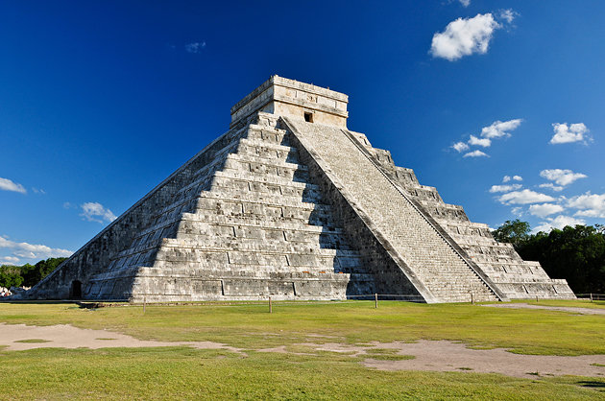

Chichen Itza is one of the Seven Wonders of the World, built by Maya Civilization in the Yucatan state of Mexico.

It is property of the Government and is maintained by Instituto Nacional de Antropologia e Historia of Mexico.